A Little About Me:
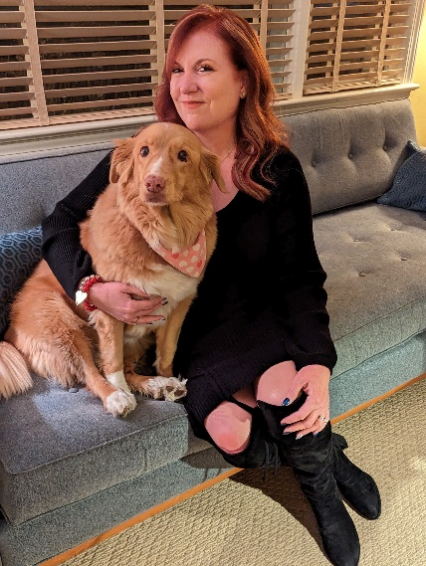

This is my 13th year teaching preschool. I love working with preschoolers and the energy and curiosity they bring to the classroom each day. This is my first year to Long Branch district but I have taught the Tools of the Mind curriculum for over 10 years. I enjoy living in Monmouth County and spend my free time with my family who live right down the street (including my adorable grandchildren! I also enjoy dancing, listening to live music and cooking. When I'm not out walking my dog, I'm out with my husband enjoying all the beautiful places Monmouth County has to offer.

